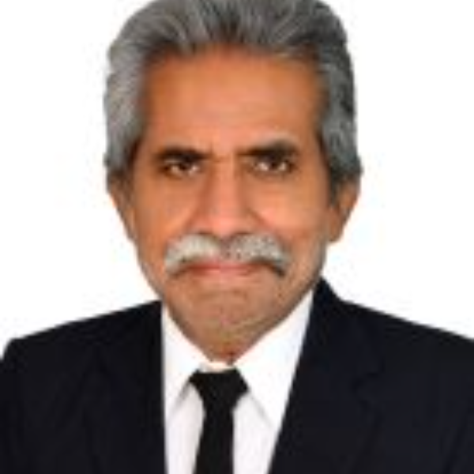



PROFESSIONAL SUMMARY

Syed Anwar KABIR S

Dean & Director

CONTACT

09566373180

syedanwarkabir007@gmail.com

45/3, Bharathiyar 4th Street, S.S.Colony. Madurai 625016, Tamil Nadu.

EDUCATION

1997 - 2001
Doctor of Philosophy (PhD)

Jamia Millia Islamia University, India, New Delhi
Ethical and Moral Values in Management.

1980 - 1982
Master of Commerce

Madurai Kamaraj University, India, Madurai
CGPA 65%

1977 - 1980
Bachelor of Commerce

Madurai Kamaraj University, India,
• Visionary Director with demonstrated capabilities in MBA education with a strong ethical orientation and commitment to stakeholders’ welfare anchored by three decades of prolific contribution to the field of management education.

• A result-oriented leader with rich and insightful experience in academic administration, Teaching, Research, Management Training and Consulting.

• Proven experience in developing academic standards and monitoring performance parameters of Faculty, staff, and students.

• Expertise in developing & and implementing policies, guidelines, and procedures to establish/maintain quality standards in compliance with Regulatory Bodies like AICTE / UGC/NAAC/NBA.

• Seasoned Academic administrator with a flair for institution-building skills.

• An effective communicator with exceptional analytical, negotiation, relationship management and problem-solving skills.

• Spearheaded the growth of Institutions / Business Schools in Kerala, Karnataka, and Tamil Nadu for about a decade.

• Was a Member of the Board of Studies of the MBA Program of Anna University of Technology, Madurai

• Had been Chairman of the Board of Examiners of MBA of Anna University, Karaikudi Zone.

• Had been Chief Superintendent of University Examinations at Anna University, Kannur University and Mangalore University.

• Had been a successful Management trainer for about two decades.

• Had been a Consultant to NLC.

EXPERIENCE

Editor 2019 - Now Scholars Retreat, Madurai, T.N.
Editor at Scholars Retreat, Madurai: As Editor at Scholars Retreat, I am responsible for editing and proofreading content for articles and books. I work closely with authors to ensure content, accuracy, and quality. My tenure as Editor has spanned over four years. Responsibilities/Achievements:

• Review manuscripts for grammar and content accuracy

• Ensure literary standards for publication

• Collaborate with authors to make editing suggestions

• Proofread articles and books before publication

Madurai
CGPA 76%

Contract Editor 2021 - 2021
Online English, Granton, TAS, Australia
LINKS






syed-kabir-88829016

AWARDS

Winner of Indira Gandhi National Gold Medal Award 2015 for Lifetime
achievement in Higher Education from the Global Economic Progress and Research Association (GEPRA), New Delhi, India.

Winner of Bharat Ratna St. Mother Theresa National Gold Medal Award 2016 for Lifetime Achievement in Higher Education from the Global Economic Progress and Research Association (GEPRA), New Delhi, India

LANGUAGES

English

Tamil

Urdu

Hindi

HOBBIES

Reading
Contract Editor at Online English, TAS, Australia: Supported daily operations of a leading online English institution by managing the editing/correction process of writing assignments. Developed and implemented quality assurance procedures to guarantee accuracy and deliverables. Assisted in creating and maintaining editorial guidelines. Responsibilities:

• Ensured accuracy of editorial assignments

• Developed quality assurance procedures

• Implemented guidelines

• Managed editing/corrections and create deliverables.

Director-MBA 2009 - 2019 Syed Ammal Engineering College, Ramanathapuram, TN.
I served as Director-MBA at Syed Ammal Engineering College for a period of 10 years. During my tenure, I was responsible for developing and implementing strategies to improve enrollment and retention rates. Additionally, I provided mentorship and guidance to a team of faculty members and students while grooming them to become efficient instructors and learners. My responsibilities and accomplishments included:

• Developing effective teaching methods

• Establishing strong relationships with industry partners

• Implementing strategies for student recruitment

• Creating opportunities for internships and placements

• Enhancing college infrastructure

• Increasing student satisfaction ratings

Director/Principal 2006 - 2008

PERSONAL INFO

Date of birth: 9 April 1960

Place of birth: Thuckalay

Nationality: Indian
Institute of Technology, Kannur, Kerala

Director/Principal at Institute of Technology, India - Held position for almost three years, directing and overseeing the institute's operations, from curriculum delivery to faculty recruitment. Responsibilities included:

• Developing and implementing policies and procedures

• Managing budget and resources

• Assessing the performance of faculty and staff

• Tracking student progress

• Leading strategic initiatives and projects

• Establishing partnerships with external organizations

• Maintaining a safe, healthy learning environment.

Director/Principal 2005 - 2005
Holy Grace Business School, Mala, Kerala

I served as the Director and Principal of Holy Grace Business School during 2005. During this tenure, I led a diverse team of teachers and other staff members to execute a successful MBA program for students. I was responsible for managing the operations, budget, and strategic planning of the business school. My responsibilities included:

• Developing academic policies

• Creating learning opportunities for students

• Initiating student-teacher mentorship programs

• Strengthening ties with industry partners

• Liaising with government agencies

• Enhancing administrative structures

• Recruiting and training faculty

Director/Principal 2004 - 2005
MSNM Besant Institute of Post Graduate Studies, Mangalore, Karnataka

As Director/Principal at MSNM Besant Institute of Post Graduate Studies, I was responsible for the overall management of the institute. I oversaw leading and managing a team of faculty members and staff members as well. During my tenure there, I was able to successfully operationalize the curriculum and introduce several initiatives that promoted student engagement. My one-year tenure also saw improved student participation and enrollment numbers. I successfully

• Led staff & faculty members

• Strengthened curriculum

• Introduced initiatives to increase student engagement

• Improved student participation & enrollment

• Managed day-to-day operations

Director 2003 - 2003 PRIST University, Tanjur, TN
As Director at PRIST University, I was responsible for the overall operations of the university. I successfully managed a wide range of programs and activities in the MBA department while developing a culture of commitment to excellence. During my tenure, I developed strong relationships with both students and staff, maintaining a positive working environment and I

• Developed and implemented operational strategies focused on improving student performance

• Facilitated collaboration between different departments to improve efficiency

•
Managed budgets and finances while meeting organizational objectives

• Established effective communication procedures with students and faculty

• Created an inclusive environment that fostered respect and appreciation for diversity

• Led teams in achieving organizational goals

• Ensured compliance with university policies and procedures

Research Associate 1983 - 2002 Management Development Institute, Gurgaon
Research Associate at Management Development Institute, India (1983-07 - 2002-02): My 19-year tenure as a Research Associate at Management Development Institute, India was characterized by hard work, dedication, and tireless effort. During this time, I was responsible for

• Developing research projects and conducting research studies

• Analyzing data and producing research reports

• Collaborating with faculty to develop innovative research ideas

• Designing curricula for a variety of training programs

• Presenting research findings at conferences

• Managing the research unit of the institute

• Training practicing managers

• Rendering consultancy services


SKILLS

Teaching

Leadership

Communication

Mentoring

Academic Administration

Stakeholder management

Institutional administration

Counselling


PUBLICATIONS
1. Kabir, S.A. (2008), Sacred in Business Ethics: Choice and Responsibility of Managers, International conference on Globalization, Development, Public policy, and Management: Emerging issues, Proceedings, Kannur University, 9-10 March 2008.

2. Kabir, S.A. (2001), Ethics in Business Management: The context of Individual (Manager), Integrity as a Moral Imperative. 41st Annual Conference. Proceedings, Institute for Advanced Philosophical Research and REALIA, Moultonborough, NH, USA.

3. Kabir, S.A. (2000), Challenges: Tom's of Maine and Alacrity, Ethics: The Guiding Light. Seventh Annual International Conference Promoting Business Ethics, Proceedings 1, 346-51. St. John’s University, New York.

4. Kabir, S.A. (1998), Alacrity's Value Management: A Synoptic Study, International Society for the Study of Work and Organizational Values [ISSWOV], Proceedings. Istanbul, Turkey. pp 131-35.

5. Kabir, S.A. (1998), Value Management Desiderata. MDI Quarterly Review. July- September, New Delhi.

6. Kabir, S.A. (1998), Perenniality of Values in Islam and the Changing Social Milieu of Muslims in India. Social Psychological Dimensions of Muslims: The Post-Independence Scenario. New Delhi: Institute of Objective Studies. pp. 223-31

7. Kabir, S.A. (1997), Challenges to Management in the 21st Century: Innovation and Creativity. Abhigyan. New Delhi. XV No 1&2, pp. 1-4.

8. Kabir, S.A. (1996), Value-Based Management: The Case on Alacrity Foundations Private Limited. Innovations in Asian Management. (ed), Dharni P. Sinha, Hyderabad: Delta Publishing House. pp. 154-69.

9. Kabir, S.A. (Summer, 1996), Ethics and Values in Business and Management. Abhigyan, New Delhi. pp. 59-65.

10. Kabir, S.A. (1995), Concept of Man according to Nahjul Balagah. International Congress on Nahjul Balagah, New Delhi.

11. Kabir, S.A. & Bhattacharya, S.K. (1993), Issues involved in Venture Capital Guidelines MDI Journal.

12. Kabir, S.A. (1992). Research Methodology in Management, Survey of Research in Management. (ED), Anmol Publications, New Delhi.

13. Kabir, S.A. & Gupta, L.C. (1991), Ratios for monitoring Corporate Health Fundamentals. New Delhi: Manas Publication,

14. Kabir, S.A. & Gupta, L.C. (1987), Shareholders Survey. New Delhi: Manas Publications

