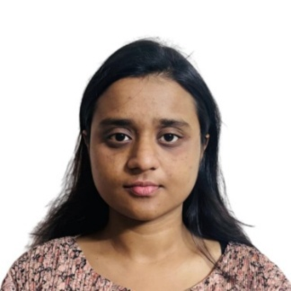
Debolina Saha,
Biomedical Researcher| PhD Scholar | Molecular Biology, Immunology & Translational Medicine Researcher
PhD Scholar and Project Associate-I
Biomaterials and Medical Devices Divisions
CSIR- Central Glass and Ceramic Research Institute
196, Raja S.C. Mullick Road, Kolkata -700 032, West Bengal (WB), India
Mobile: +91-8583890916
Email: debolinasaha83@gmail.com,
Google Scholar: https://scholar.google.com/citations?user=4KQBrDgAAAAJ&hl=en

PROFFESIONAL SUMMARY__________________________________________________________
Biomedical Researcher, AcSIR PhD Scholar, and Project Associate-I at CSIR-CGCRI, Kolkata, with expertise in Molecular Biology, Cell Biology, Microbiology, Immunology, Biomaterials, Regenerative Medicine, Stem Cell Engineering, Medical Devices, and 3D Bioprinting. Experienced in mammalian cell culture, qRT-PCR, flow cytometry, immunological assays, osteogenic differentiation, antimicrobial evaluation, and biomaterial characterization. Author of 7 SCI-indexed publications and co-inventor of an international patent family (India, USA, and Europe), with experience in scientific writing, patent drafting, and translational biomedical research.

EDUCATION________________________________________________________________________

Degree | Institute/University | Year of Graduating | Subject(s) of Specialization | Grade
Ph.D. | CSIR-Central Glass and Ceramic Research Institute, Kolkata, West Bengal | Ongoing (Enrollment: January 2025) | Molecular Biology, Cell Biology, Regenerative Medicine, Biomaterials, Mechanobiology, 3D Bioprinting, Translational Biomedical Research | 8.5
M.E. | Jadavpur University, Kolkata, West Bengal | 2023 | Biomaterials, Tissue Engineering, Regenerative Medicine, Cell-Biomaterial Interaction, Biomedical Engineering | 8.63
B. Pharm | Guru Nanak Institute of Pharmaceutical Science and Technology (MAKAUT), Kolkata, West Bengal | 2021 | Pharmaceutical Sciences, Microbiology, Pharmacology, Biochemistry, Pharmaceutical Analysis, Biostatistics | 9.17  (2nd Rank in the batch)

RESEARCH INTERESTS______________________________________________________________
Molecular Biology, Cell Biology, Biochemistry, Microbiology, Immunology, Stem Cell Engineering, Cancer Biology, Regenerative Medicine, Biomaterials, Mechanobiology, 3D Bioprinting, Translational Biomedical Research.

RESEARCH PROFILE SUMMARY
- SCI Publications: 7 & Patent Applications: 3 (India, USA, Europe) and Trademark Applications: 1
- Conference Presentations: 15; GPAT AIR: 1866 (2021)

TECHNICAL EXPERTISE____________________________________________________________
Molecular Biology: qRT-PCR, Primer Design, Gene Expression Analysis, ELISA, SDS-PAGE, Agarose Gel Electrophoresis, and Flow Cytometry-Based Cellular Analysis.
Cell Biology: Mammalian Cell Culture (hBMSCs, MC3T3-E1, L929, MCF-7, MCF-10A), Cell Proliferation Assays, Live/Dead Assay, Osteogenic Differentiation, Cell-Material Interaction Studies, Fluorescence Microscopy.
Biochemistry: ALP Activity, Collagen Quantification, DNA Estimation, Mineralization Assays, Protein Quantification.
Microbiology: Antimicrobial Susceptibility Testing, Zone of Inhibition (ZOI), Bacterial Growth & Viability Assays, Antibacterial Biomaterial Evaluation.
Pharmaceutical Sciences: Formulation Development, Pharmaceutical Analysis, Drug-Excipient Compatibility, Drug Release Studies, Biopharmaceutics & Pharmacokinetics Fundamentals.
Bioinformatics: STRING Analysis, PPI Networks, GO Enrichment, KEGG Pathway Analysis, Functional Annotation.
Biofabrication & Tissue Engineering: DLP & Volumetric 3D Bioprinting, Bioink Development, hBMSC Spheroids, Scaffold Fabrication.
Biomaterials & Medical Devices: FTIR, XRD, FESEM, Rheology, Mechanical Testing, Electrospinning, Antibacterial Implant Evaluation.
Scientific Writing & Research Development: SCI Manuscripts, Review Articles, Literature Review, Research Proposals, Patent Drafting, Technical Documentation, Scientific Presentations.
Immunology & Cell Analysis: Flow Cytometry (FACS), Immunophenotyping, Cell Cycle Analysis, Apoptosis Assessment, Fluorescence-Based Cellular Assays, Immunological Evaluation of Biomaterials.

RESEARCH EXPERIENCE___________________________________________________________
- PhD Scholar | CSIR CGCRI, Kolkata | Ongoing (Registration under AcSIR in Jan 2025)
Title: Development of Novel Non-Invasive Magneto-Acoustic Stimulation for Bone Regeneration as a Standalone and Adjuvant with 3D Bioprinted Scaffolds
Working on the development of a non-invasive regenerative platform integrating magneto-acoustic stimulation with advanced 3D bioprinted scaffolds for bone regeneration. Research involves the development of SilMA/GelMA-based bioinks; DLP and volumetric 3D bioprinting; hBMSC spheroid culture; biomaterials characterization; osteogenic differentiation; and molecular mechanism studies through Bioinformatics-driven transcriptomic interpretation, pathway enrichment analysis, protein-protein interaction network analysis, and multi-omics data interpretation of published datasets. Mechanistic investigations include membrane depolarization, intracellular calcium signaling, mechanosensitive ion channels (PIEZO1, TRPV4, VGCCs), and osteogenic pathway analysis through STRING, GO, and KEGG enrichment tools. Experimental studies include flow cytometry-based cellular analysis, immunological evaluation, stem cell engineering, and mechanobiological pathway studies.
Supervisor: Dr. Subhadip Bodhak & Dr. Vamsi Krishna Balla

Project Associate-I | CSIR-CGCRI, Kolkata | Sept 2023 - Present
Project: Novel Non-Invasive Magneto-Acoustic Regenerative Strategy for Promoting Bone Regeneration
Investigating the synergistic effects of Low-Intensity Pulsed Ultrasound (LIPUS) and Static Magnetic Field (SMF) stimulation on osteoblasts and hBMSCs using 2D and 3D cell culture models. Research includes cell viability, proliferation, osteogenic differentiation, ALP activity, mineralization, gene expression analysis, mechanobiology studies, scientific manuscript preparation, patent drafting, and translational medical device development.
Supervisor: Dr. Subhadip Bodhak & Dr. Vamsi Krishna Balla

Masters of Engineering in Biomedical Engineering | Jadavpur University | 2021 - 2023
Title: Development of Multifunctional Silk Fibroin/PCL-Based Electrospun Nanofibers for Tissue Regeneration
Developed electrospun silk fibroin/PCL nanofibrous scaffolds and silver-doped antibacterial biomaterials for tissue regeneration. Also, reduced graphene oxide was synthesized via a green one-pot reduction method using Calendula officinalis extract, and its physicochemical, biological, and antimicrobial properties were evaluated.
Supervisor: Dr. Subhadip Bodhak, CSIR-CGCRI, Kolkata & Dr. Piyali Basak

Bachelor of Pharmacy | MAKAUT | 2017 - 2021
Title: Antibacterial Activity of Herbal Cream Formulated from Aqueous Extract of Psidium guajava Stem Bark Against Staphylococcus aureus and Escherichia coli
Formulated and evaluated an herbal antimicrobial cream and investigated its antibacterial efficacy against Gram-positive and Gram-negative bacterial strains through microbiological and pharmaceutical formulation studies.
Supervisor: Ms. Jeenatara Begum

AWARDS AND ACHIEVEMENTS______________________________________________________
•AICTE Regional Level Chatra Viswakarma Award 2020 (Pharma Warrior, APP)
•Graduate Pharmacy Aptitude Test (GPAT), National Level Entrance Examination for entry into M. Pharma, 2021, AIR: 1866

SOCIETY MEMBERSHIP_____________________________________________________________
- Indian Pharmaceutical Graduate Association, 2019 - Present

PATENTS / PUBLICATIONS / PRESENTATIONS SUMMARY______________________________
- 3 Patent applications (1 Indian, 1 US, 1 Europe) & 1 Trademark Application
- Total Peer-Reviewed Scholarly Publications: 7 peer-reviewed Journal articles.
- Total Conference Presentations: 15 (6 Contributory Oral presentations, 9 poster presentations)

(A) PATENTS
Vamsi Krishna Balla, Subhadip Bodhak, Somoshree Sengupta, Siddik Sarkar, Hasanur Rahaman, Sweta Shaw, Debolina Saha, A non-invasive magneto-acoustic apparatus for healthy tissue healing, regeneration, and cancer regression, INDIAN Patent App. 202411053207, Application date: 11/07/2024; USA Patent Application No. 19/26574, Application date:10/07/2025, European Patent Application No. 25187610.8, Application date: 04/07/2025; Original Assignee: Council of Scientific and Industrial Research, Anusandhan Bhawan, 2 Rafi Marg, New Delhi 110001, Delhi, India.
(B) TRADEMARKS_________________________
Filed 1 trademark applications for healthcare technologies (TRL 5/6) developed from R&D projects during the assessment period. Details are given below.
- iSMART™ is a trademark filed for our patented non-invasive magneto-acoustic apparatus (protected under Indian Patent Application No. 202411053207, dated 11.07.2024) designed to promote healthy tissue healing, regeneration, and cancer regression through targeted bio-physical stimulation.

TECHNOLOGY/PRODUCT DEVELOPMENT & COMMERCIALIZATION__________________
The following technologies represent my key translational contributions in advanced biomaterials, orthopaedic implants, regenerative medicine, and non-invasive therapeutic platforms, progressing from laboratory-scale innovation to prototype validation, patent protection, industry engagement, and commercialization readiness.

- Contributed to the development of i-SMART™, an indigenous wearable magneto-acoustic regenerative therapy platform integrating Low-Intensity Pulsed Ultrasound and static magnetic field stimulation. The platform generates controlled magneto-acoustic coupling, physiologically relevant acoustic pressure, and micro-electric potentials to mimic endogenous bioelectrical cues for bone regeneration and cancer regression. The technology has reached TRL 5/6, supported by prototype development, animal validation, patent filings in India, USA, and Europe, and industry engagement.

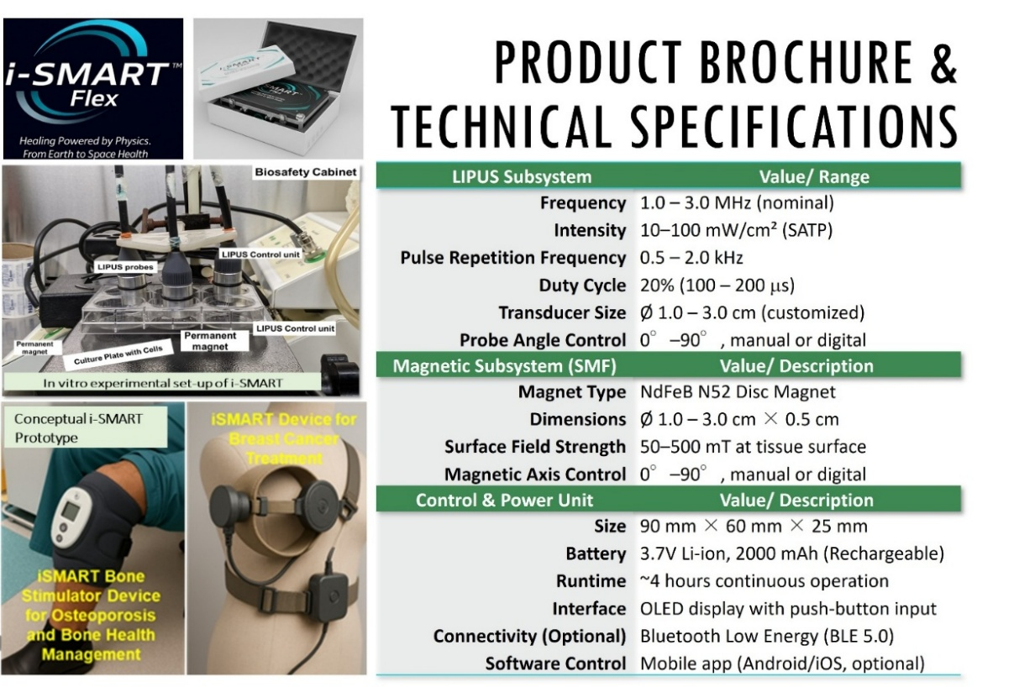
Patent: Indian Patent Application No. 202411053207 (Filed: 11/07/2024); USA Patent Application No. 19/26574; European Patent Application No. 25187610.8; TRL: 5/6 (TRL 5/6 - Prototype development with animal validation and technology evaluation); Industry Engagement: IF MedTech (Mumbai). Publication: “Debolina Saha, Ankush Pratap Singh, Vamsi Krishna Balla, Subhadip Bodhak, “Magneto-acoustic coupling-generated synergistic electromechanical stimulation accelerates osteogenesis in vitro” in Acta Biomaterial (under review).

RESEARCH PUBLICATIONS_________________
- Research and Review Article Publications
- Tapas Das, Debolina Saha, Ankush Pratap Singh, Vamsi Krishna Balla, Subhadip Bodhak, “Multimaterial Synergy in Bioactive Polyetherketoneketone Composites for Advanced Skeletal Reconstruction”, Journal of the American Ceramic Society, (I.F.: 4.2)
- Debolina Saha, Piyali Basak, Subhadip Bodhak, “Silver Doped PCL-Silk Fibroin Electrospun Nanofibrous Scaffolds with Synergistic Osteogenic and Antimicrobial Activity”, ChemBioChem, Publication date: 01/06/2026 (I.F.: 2.8)
- Debolina Saha, Pratik Das, Tathagata Adhikary, Sk Hasanur Rahaman, Piyali Basak, Subhadip Bodhak, “One‐Pot Approach Reduction of Graphene Oxide Through Calendula officinalis for Promising Biomedical Applications”, International Journal of Applied Ceramic Technology, Publication date: 24/03/2026 (I.F.: 2.3)
- Khushi Bijalwan, Karthiga Parthiban, Sutanu Dutta, Debolina Saha, Sumana Ghosh, “In-vitro evaluation of hydroxyapatite reinforced glass-ceramic composites for biomedical applications”, Progress in Biomaterials, Publication date: 30/09/2025 (I.F.: 4.4)
- Srikrishna Manna, Milan Kanti Naskar, Debolina Saha, Prabir Pal, Samar Kumar Medda “Long- term stability of Ag NPs in a room temperature cured SiO₂–ZrO₂ crosslinking hybrid robust coating towards enhanced weather resistance properties and its antibacterial applications”, New Journal of Chemistry, Volume 49, Number 17,7 May 2025, Pages 6849–7274 (I.F.: 2.7)
- Anustup Chakraborty, Subhadip Bodhak, Indrajit Tah, Shashi Kant, Debolina Saha, Krishna Dey, Neelima Gupta, Manasi Ghosh, Sucheta Tripathy, Amarnath Allu, Kaushik Biswas, “Tailored Bioactive Glass Coating: Navigating Devitrification Towards a Superior Implant Performance”, ACS Biomaterials Science & Engineering, Publication date: 24/07/2024 (I.F.: 5.4)
- Subhadip Banerjee, Debolina Saha, Rohit Sharma, Wuttichai Jaidee, Panupong Puttarak, Nathorn Chaiyakunapruk, Rawiwan Chaoroensup, “Phytocannabinoids in neuromodulation: From omics to epigenetics”, Journal of Ethnopharmacology, Volume 330; 10 August 2024, 118201, Publication Date: 30/04/2024 (I.F. 4.8)
II. Manuscript Under Submission
Debolina Saha, Ankush Pratap Singh, Vamsi Krishna Balla, Subhadip Bodhak, “Magneto-acoustic coupling-generated synergistic electromechanical stimulation accelerates osteogenesis in vitro” in Acta Biomaterial

CONFERENCE PRESENTATIONS___________
Presentation Summary: Total 15 (6 Contributory Oral presentations, 9poster presentations)
- Oral Presentations
- Debolina Saha, Ankush Pratap Singh, Vamsi Krishna Balla, Subhadip Bodhak, “In Situ Magneto-Acoustic Electro-Mechanical Coupling for Enhancement of Osteogenic Differentiation through Synergistic Biophysical Stimulation”, Indian Pharmaceutical Association Annual Convention, NextGen PHARMA 2026, IIT Kharagpur Research Park, New Town, Kolkata, during March 14-15, 2026. (Best poster presentation award)
- Debolina Saha, Subhadip Bodhak, Piyali Basak, “Silver (Ag) Nanoparticles Doped Multifunctional Silk Fibroin-Polycaprolactone (SF-PCL) Nanofibrous Composite Scaffolds with Enhanced Biocompatibility and Antibacterial Properties for Bone Regeneration”, National Seminar on Industrial Ceramics: Challenges, Opportunities and Sustainability (ICCOS), at CSIR-CGCRI on June 13-14, 2024.
- Debolina Saha, Pratik Das, Tathagata Adhikari, Piyali Basak, “A Short Review on the Impact of Graphene-Based Nanomaterials (Graphene oxide and Reduced Graphene Oxide) in the Biomedical Industry”, 2nd National Conference on Biotechnology and One Health, Department of Biotechnology at Brainware University on 30th May,2022.
- Debolina Saha, Jeenatara Begum, “Antibacterial Activity of Herbal Cream Formulated from Psidium guajava Leaf Extract Against Staphylococcus aureus & E. coli”, International conference on Present Scenario of Availability and Bioequivalence Studies and its Regulatory Affairs in Jadavpur University, 12th February 2022.
- Debolina Saha, Jeenatara Begum, “Future Aspect of 3D and 4D printing Technology in Health Care”, in Greentech Virtual Vision contest 2020 at Green University, Bangladesh, in December 2020.
- Debolina Saha, Jeenatara Begum, “Formulation and Evaluation of Herbal Cream from Aq. Extract of Psidium guajava Stem Bark”, in National Workshop on “Pharmacist Improving Therapeutic Outcome” IICE, Jadavpur University on 23rd November, 2019.

- Poster Presentations
- Debolina Saha, Ankush Pratap Singh, Vamsi Krishna Balla, Subhadip Bodhak, “Predicting the Synergism of Novel Non-Invasive Magneto-Acoustic Regenerative Strategy (MARS) for Promoting Bone Regeneration” International Conference on Frontiers in Translational Bioengineering for Healthcare (FTBH-2025), Birla Institute of Technology, Mesra, Ranchi, during May 8-10, 2025.
- Debolina Saha, Vamsi Krishna Balla, Subhadip Bodhak, “Non-invasive Magneto-Acoustic Regenerative Strategy (MARS) for promoting bone regeneration: An unexplored approach utilizing 2D and 3D scaffolds”, in Emerging Trends in Advanced Materials (ETAM), 2025 held at CSIR-CGCRI, Kolkata, during February 6-7, 2025.
- Debolina Saha, Vamsi Krishna Balla, Subhadip Bodhak, “Novel Non-Invasive Magneto-Acoustic Strategy for Bone Regeneration”, in National Symposium on "Molecular Basis of Life: Health, Disease and Diversity held at Presidency University, Kolkata during 28-30 November, 2024.
- Debolina Saha, Sk. Hasanur Rahaman, Subhadip Bodhak, Piyali Basak, “Silver Nanoparticles Doped Multifunctional Silk Fibroin-Polycaprolactone Nanofibrous Composite Scaffolds with Enhanced Biocompatibility and Antibacterial Properties for Skin Wound Regeneration”, in 87th Annual Session of the Indian Ceramic Society (ICEECG 2023) held at CSIR-CGCRI, Kolkata during December 19-21, 2023.
- Debolina Saha, Pratik Das, Subhadip Bodhak, Piyali Basak, “Green Synthesis and Characterization of Reduced Graphene Oxide (RGO) Using the Calendula Officinalis Mother Tincture and Evaluate its Antibacterial Activity in vitro” in BIOCOM, National Workshop 2022 held at CSIR-CGCRI, Kolkata on 20th December, 2022.
- Debolina Saha, Pratik Das, Subhadip Bodhak, Dr Piyali Basak, “One Pot Green Synthesis and Characterization of Reduced Graphene Oxide-Calendula Officinalis Nanocomposite for Potential Biomedical Applications”, in National Seminar on New Education Policy & Regulation: In Pharmacy, PCI-Bharat Technology at Rabindra Tirtha on 6th May,2022. (Best poster award)
- Debolina Saha, Jeenatara Begum, “Role of 3D & 4D Printing in Pharmaceutical Industry in 21st Century”, at IPGA 34th National Conference in Biswa Bangla Convention Centre, on 5th December, 2020.

LIST OF REFERENCES__________________________________________________________
- Dr. Subhadip Bodhak, PhD (M. E. & Ph.D. Supervisor)
Senior Principal Scientist (Scientist F)
Biomaterials and Medical Devices Division
CSIR-Central Glass and Ceramic Research Institute,
Associate Professor, Faculty of Engineering Sciences, AcSIR Bioceramics and Coating Division
196 Raja SC Mullick Road, Kolkata 700032
Mobile 91-8910902562, E-mail: sbodhak@cgcri.res.in, sbodhak@gmail.com

- Dr. Vamsi Krishna Balla, PhD (Ph.D. Co-Supervisor)
Chef Scientist
Biomaterials and Medical Devices Division
CSIR-Central Glass and Ceramic Research Institute
Associate Professor, Faculty of Engineering Sciences, AcSIR Bioceramics and Coating Division
196 Raja SC Mullick Road, Kolkata 700032
Tel: +91-033-2429 4179; 2473 3469/76/77/96, Extn: 3219
Mobile: + 91-9088011776
E-mail: vamsi.cgcri@csir.res.in , vamsi23@yahoo.com
- Dr. Piyali Basak, PhD (M.E. Supervisor)
Associate Professor, Director
School of Biosciences and Engineering, Jadavpur University, Kolkata
188, Raja Subodh Chandra Mallick Rd, Jadavpur, Kolkata, West Bengal 700032
Mobile: +91 99033 03592,
Email: piyali.basak@jadavpuruniversity.in

