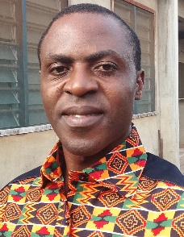
Emmanuel Ejuh CHE received his DIPET I and II in 2012 and 2014, respectively, in Electro-techniques from the University of Bamenda; he received an M.Eng in 2018 in electrical power systems from the University of Buea, all in Cameroon. He is currently awaiting a PhD award in the Faculty of Engineering and Technology, serving as a graduate assistant lecturer in the same faculty and at other private universities to date. Before this, he served as a technical secondary school teacher in the Electrical Technology department, working with private power system companies on the installation of industrial and commercial electrical systems, including the construction of low-voltage transmission lines. His research interests are power systems analysis and renewable energy integration into conventional grids. He is presently working on the transformation of the Cameroon Northern Interconnected grid for optimal Solar PV injections, with a feasibility and economic analysis of net-metering adoption research article in view.

